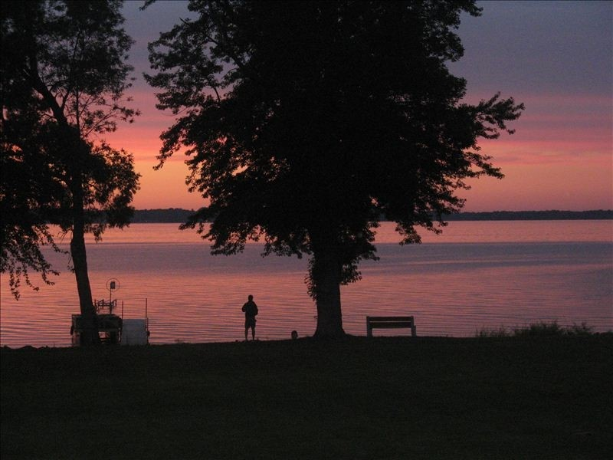 | Maple Beach Property Holders Newsletter
#7 |  | JULY 2017
Your  OFFICERS  And  DIRECTORS  Nathaniel Ross  President  920-723-7719  Nathanielross17@gmail.com  Brad Mommaerts  Vice President  608-561-6302  moe1816@yahoo.com  Debi  Rossi  Treasurer  630-750-4285  praizegodtoday@aol.com  Allison Epker  Secretary  920-220-9427  Allison_epker@yahoo.com  Katherine Kinderman  608-234-1532  kkinderman@aol.com  Thomas Nolfi  773-875-3831 dclub79@aol.com  Joe  Rossi  312-501-4337  Balloonsbyjr@aol.com | Our Mission Statement:  The Maple Beach Association exists to improve the overall quality of life in the MBPHA area and to support the commonwealth of its members, which ultimately enhance homeowner’s property value.  If you paid your 2017 dues, thank you. If you haven’t, please participate in MBPHA in what perpetuates a long history of dynamic neighbors making a difference in our community! Checks should be made payable to: Maple Beach Property Holders Association, Inc. Mail to: MBPH, Inc. PO Box 311, Edgerton, WI 53534  A Message from Our New President: I would like to thank all of the other board members for their support. I look forward to serving all of you, and being able to help our community grow. I love the neighborhood I live in and can’t wait to meet more of you soon.  Thanks, Nat Ross  Agenda for general meeting October 28, 2017 at 8:30am at Mallwood Estates Clubhouse  Meeting Order of Business:  1. Call meeting to order  2. Roll Call of officers present  3. Approval of Meeting Minutes  4. Treasurer’s report  5. Reading of Communications  6. Report of Special Committees  7. Unfinished business  8. New business  - Vote for only paid members to have voting rights  - Adjournment  Rummage-O-Ramma scheduled for September 22nd-24th! This will consist of MBPH households holding garage/yard sale at their homes if they would like to. Participation is not required. An event to get to know members of your community!  If you are able and willing to receive your meeting minutes and agenda via e-mail please e-mail us at maplebeachassoc@yahoo.com and we will get you added to the list. Each household that we can set up on e-mail helps to save the association money and we can also send a reminder at the time of events. Also a note that all emails will be sent Blind Copy to keep each property holders e-mail private. Emails addresses will not be shared or sold. Check us out on our face book page! Visit our new website www.maplebeachpropertyholders.com!  On back are the minutes from the meeting on June 3rd, 2017---→

